Source https://pinpointtraveler.com/tour/osaka-night-food-tour/
__________________________________________________________

Authentic Osaka Night Food Experience
__________________________________________________________
★★★★★ 4.8/5 23 reviews

Add to wishlist ♡

__________________________________________________________

3 hours | From €75 per person

🏕  Image | 🏕  Image | 🏕  Image | 🏕  Image | 🏕  Image | 🏕  Image

__________________________________________________________
About This Tour
Experience Osaka’s vibrant food scene on a 3-hour night food tour, guided by a local expert. You’ll explore the Tenma and Kyobashi neighborhoods, tasting delicious local delicacies while learning about the rich culture and history of these areas. From savory street foods to hidden gems, this is an authentic experience you won’t forget. Enjoy a relaxed, small-group setting with a maximum of 6 participants for a personalized and intimate experience.
__________________________________________________________
What’s Waiting for You
- Duration: 3 hours (approx.)
- Group Size: Small-group, 6 participants max (or 8 for private groups)
- Languages Available: English
- Season: Available year-round
- Meeting Point: Outside Tenma Station, making it easy to find and accessible via both subways and the JR Loop Line. The tour ends at Kyobashi Station, where it's easy to travel to other parts of Osaka or Kyoto.
__________________________________________________________

Check Dates & Availability

Select participants: (Age 99 and younger) - 1 +

Choose date:
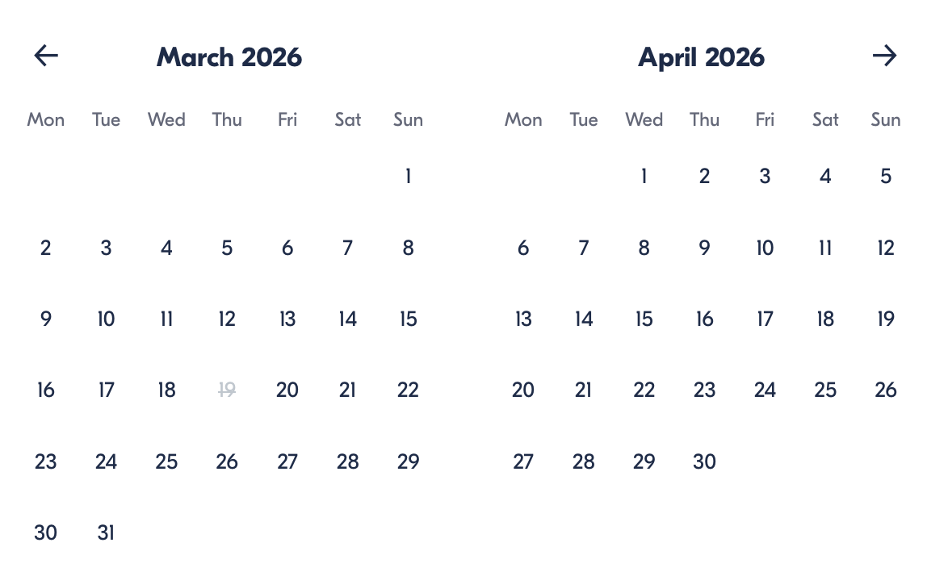

Check Availability

opens:

Participants: 2 March 16, 2026

Authentic Osaka Night Food Experience

- Duration: 3 hours (approx.)
- Offered in: English
- Starts at: 10:30 AM

Cancellation:

- Full Refund up to 24 Hours Before Departure: Cancel up to 24 hours before departure for a full refund. Notify us via email, and we’ll confirm your cancellation.

Price breakdown: 2 Participants x €75

Total: €150

The total price includes all taxes and fees.

Add to cart Book now

__________________________________________________________
Tour Features
- Local Food Exploration: Taste up to 15 dishes at 3 unique restaurants.
- Hidden Gems: Visit authentic, lesser-known eateries in Tenma and Kyobashi.
- Cultural Insights: Learn about Osaka’s culinary history and local life from your expert guide.
- Inclusive: 3 drinks (alcoholic or non-alcoholic) included, with the option to purchase more.
__________________________________________________________
Detailed Itinerary
- Day 1

- Start in Tenma: Begin your adventure in the Tenma district, famous for its traditional food stalls and authentic Japanese street foods. Enjoy snacks and drinks as your guide shares the area's history.
- Visit 3 Local Eateries: Explore the best hidden spots for Osaka’s iconic foods. Experience everything from fried snacks to savory treats, all while learning about the rich local culture and food traditions.
- Kyobashi Neighborhood: After Tenma, venture to the Kyobashi area, known for its bustling nightlife and traditional eateries. Your guide will take you to off-the-beaten-path restaurants where you’ll taste even more delicious dishes, finishing with a sweet dessert or drink.
__________________________________________________________
Included in Price
- English-speaking local guide
- 3 unique food stops (at least 15 dinner items)
- 3 drinks (alcoholic or non-alcoholic)
- Walking tour of Tenma & Kyobashi neighborhoods
- Cultural insights and stories
__________________________________________________________
Not Included
- Additional drinks beyond the 3 provided
- Meals outside of the tour
- International flights
__________________________________________________________
Who Should Avoid This Tour
- Pregnant Travelers: Due to the physical nature of the tour and the fact that it involves walking through crowded areas and dining at various locations, it may not be comfortable for pregnant travelers.
- Travelers with Food Allergies: While we strive to accommodate dietary preferences, we recommend those with severe food allergies contact us in advance to ensure that their needs can be met.
- Young Children: The tour is designed for adults and older children. Younger children may find the walking distances and certain food types challenging or uncomfortable.
- Those with Limited Mobility: The tour involves walking through busy neighborhoods, and some locations may not be wheelchair accessible.
__________________________________________________________
Important Trip Info
- The legal drinking age in Japan is 20.
- All participants must be 13+ to participate in this experience.
- Please wear comfortable shoes, as there will be some walking involved.
- Dress for both indoor and outdoor environments.
- Arrive a bit early, as we cannot wait for late-comers.
__________________________________________________________

Cancellation Policy

Full Refund up to 24 Hours Before Departure
Cancel up to 24 hours before departure for a full refund. Notify us via email, and we’ll confirm your cancellation.
Changes Made by Us
We may modify your itinerary due to unforeseen circumstances. In case of significant changes, we’ll offer an alternative tour or refund the price difference.
Circumstances Beyond Our Control
We are not liable for cancellations or changes due to events such as war, natural disasters, or severe weather.
Your Responsibility
You are responsible for your actions. If your behavior disrupts others or causes damage, you’ll be held liable for any costs incurred.
__________________________________________________________
What Our Clients Are Saying

Overall rating  4.8/5  ★★★★★  Based on 23 reviews | Review summary  Guide 4.5/5  Transportation 4.6/5  Service 4.7/5  Organisation 4.5/5

Filter  - All traveller types  - Couples  - Group of friends  - Families  By star rating  - All star ratings  - 5 stars  - 4 stars  - 3 stars  - 2 stars  - 1 star | Search reviews (e.g., guide)  Sort by:  - Top picks  - Latest reviews  - Best ratings  - Lowest ratings
__________________________________________________________
★★★★★ Maximilian – Germany
A fantastic experience! The tour gave us a unique insight into Osaka’s food culture, and our guide was knowledgeable and friendly. The variety of food was exceptional, and the stops were all authentic, away from the typical tourist spots!

★★★★★ 이영진 – South Korea
오사카에서의 밤을 즐기는 최고의 방법! 음식이 정말 다양하고 맛있었어요. 가이드도 매우 친절하고, 설명이 정말 좋았어요. 오사카의 숨겨진 맛집들을 알게 되어 너무 좋았습니다!

★★★★☆ Oliver – United Kingdom
A wonderful night out exploring the authentic side of Osaka! The food was fantastic, but I would have liked a bit more time at each stop to fully enjoy everything. The guide was great though, and the tour was well-paced overall.

See more reviews
__________________________________________________________

Meta tags

Page - Authentic Osaka Night Food Experience

Title: Authentic Osaka Night Food Experience | Travellio Global

Description: Explore Osaka’s culinary landscape on a 3-hour night food tour. Taste authentic local dishes, visit hidden gems, and learn about Osaka’s rich food culture.

H1 - Authentic Osaka Night Food Experience
__________________________________________________________

